Available online at [www.sciencedirect.com](http://www.sciencedirect.com/)



AASRI Procedia 3 (2012) 488 – 494

2012 AASRI Conference on Modeling, Identification and Control

Static Aeroelastic Response Analysis of Aircrafts Based on CFD Pressure Distribution

Yaokun Wanga, Zhiqiang Wana, Chao Yanga, Yunzhen Liua *

*Beijing University of Aeronautics and Astronautics, Beijing 100191, P.R.China*

Abstract

An analysis method for static aeroelastic response considering the effect of Computational Fluid Dynamics (CFD) aerodynamic pressure distribution was developed in this paper. The aerodynamic pressure and the steady aerodynamic influence coefficient matrix were computed by the high-order panel method and then were corrected according to CFD pressure distribution on the 3D body-surface panel element. The static aeroelastic response was solved by modal method coupling with the structural model. A high-aspect-ratio wing was taken as an example to evaluate the analysis method, and the aerodynamic pressure obtained by CFD method with Euler equation was used for aerodynamics correction on 3D body-surface panel element in this study case. The method was then evaluated by comparing the results with those from the low-order panel method using external aerodynamic pressure and the high-order panel method. The results indicate that the method could provide correct results. The method could be used in the preliminary stage as well as in the detailed stage of aircraft design to provide design guideline of static aeroelastic response analysis.

© 2012 The Authors. Published by Elsevier B.V. Open access under [CC BY-NC-ND license.](http://creativecommons.org/licenses/by-nc-nd/3.0/)

© 2012 Published by Elsevier B.V. Selection and/or peer rev[iew under responsib](http://creativecommons.org/licenses/by-nc-nd/3.0/)ility of American Applied Science Research Institute

Selection and/or peer review under responsibility of American Applied Science Research Institute

*Keywords:* Static aeroelastice response, body-surface panel, CFD pressure distribution, aerodynamic influence coefficient, modal mothed.

* Corresponding author. Tel.: +86-13811950504, +86-10-82316034.

*E-mail address:* [yaokun54@yahoo.com.cn.](mailto:yaokun54@yahoo.com.cn)

2212-6716 © 2012 The Authors. Published by Elsevier B.V. Open access under [CC BY-NC-ND license.](http://creativecommons.org/licenses/by-nc-nd/3.0/)

Selection and/or peer review under responsibility of American Applied Science Research Institute doi:10.1016/j.aasri.2012.11.077

1. Introduction

The static aeroelastic problem determines flight load, lift loading, drag, efficiency of control, trimming of the aircraft, static stability and maneuvering quality on steady flight conditions. It also has an influence on modern aircraft with high performance which cannot be neglected on the aspects of performance, static and dynamic stability, etc. At the same time, in the preliminary and detailed design phase of aircraft, a more precise and highly efficient analysis method is demanded, as the design cycle of modern aircraft is shorter.

It has become common that the static aeroelastic analysis is based on linear aerodynamic forces calculated with the low-order panel method or high-order panel method in the early phase of aircraft design. Low-order panel method is highly efficient and easy to use, but the analysis results are rough. High-order panel method can achieve a higher accuracy than the low-order panel method. The aerodynamic model is based on three- dimensional solid geometry. Therefore, complex aircraft configurations can be modeled. With the high-order panel method, the aerodynamic load distribution of the leading and trailing edges of the wing can approximate the actual pressure distribution well, and the flow field can be accurately predicted. However, both of the above aerodynamic force methods are linear, they have a lower accuracy compared with CFD method, especially in the circumstance of high subsonic and transonic. Low-order panel method using external aerodynamic forces is generally used for static aeroelastic analysis in the detailed aircraft design stage, it uses CFD or experimental aerodynamic forces data and has a higher accuracy. However, this method cannot get aerodynamic force distribution on the upper and lower surface of the wing, as it is based on flat aerodynamic model. There are some limitations in the aspects of aerodynamic configuration design and wind-tunnel tests that are related to pressure distribution correction. Therefore, it is required to explore a static aeroelastic response analysis method based on surface element and leaded in nonlinear pressure distribution, which has a high computational efficiency.

A static aeroelastic analysis method based on surface element and leaded in CFD pressure distribution, which is applied to the early and detailed design stage of aircraft, is recommended in this study. Derived from external nonlinear steady aerodynamic pressure distribution data, correction factor is used to make amendments to aerodynamic influence coefficient matrix and steady aerodynamic pressure distribution of high-order panel method based on three-dimensional surface element. The static aeroelastic response analysis result is accurate and high efficiency because of combining with modal method to make an elastic revision.

1. Methodology
   1. *Aerodynamic forces analysis*
      1. *Aerodynamic forces analysis based on body-surface panel element*

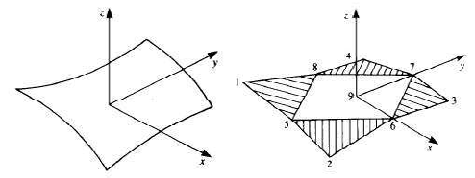

Fig. 1. Approximation of a cured panel by five flat subpanels

The surface shape and singularity strength distribution over an arbitrarily shaped panel can be approximated by a polynomial of a certain degree. In low order or first order panel method, an arbitrary

panel is approximated by *z*  *a*0 , while in high order panel method, it can be approximated by five flat subpanels1 (Fig.1), and the second order approximation is2:

*z*  *a*0  *b*1 *x*  *b*2 *y*  *c*1 *x*2  *c*2 *xy*  *c*3 *y*2

The source distribution on this element is approximated by a first-order polynomial:

**  *x*0 , *y*0   ** 0  ** *x x*0  ** *y y*0

*(1)*

*(2)*

Where *x0*, *y0 * are the panel local coordinates, *σ0* is the source strength at the origin, and *σ0*, *σx* and *σy* are three constants. The contribution of this source distribution to the potential  and to the induced velocity (*u*, *v*, *w*) can be evaluated by performing the integral

  *F*

** , ** , ** , ** , ** , ** , ** , ** , **

  *ƒ*

** , ** , ** , ** , ** , ** 

*(3)*

 *u*, *v*, *w*  *G*

*D*

1 2 3 4 5 6 7 8 9

*D*

0

*x y xx xy yy*

*D*

** , ** , ** , ** , ** , ** , ** , ** , **

  *g*

** , ** , ** , ** , ** , ** 

*(4)*

Where the functions *F*, *G*, *ƒ*, and *g* are linear matrix manipulations, which depend on the geometry only. Also, note that *µ0*, *µx*, *µy*, *µxx*, *µxy* and *µyy* are the five basic unknowns for each panel, and *µ0*,  , *µx* can be evaluated based on these values . As a result, for each panel, only five unknown doublet parameters are left. At each panel, Neumann boundary condition or Dirichlet boundary condition is imposed to solve for the source and doublet strength. Due to the strength and gradient continuity of the doublet on the panel corner point, the function to describe source and doublet can be attended.3,4 The pressure coefficient, aerodynamic derivatives and so on can be obtained by solving the small disturbance potential equation based on these

1 2 3 4 5 6 7 8 9

*D*

0

*x y xx xy yy*

boundary conditions.

* 1. *Aerodynamic correction method*
     1. *Aerodynamic ƒorces correction*

High-order panel method is a linear aerodynamics method, there are certain limitations in the calculation of high subsonic and transonic, and needed to be amended with external aerodynamic data.5 The amendments require nonlinear date mainly from CFD calculations aerodynamic forces.6 The correction of high-order panel method is based on solving CFD aerodynamics correction matrix and aerodynamics

influence coefficient matrix (AIC), thus the cell and node aerodynamic results.7,8 The correction matrix [*C\**] is obtained as:9

*CPgiven*    *AIC* *C* **W* 

*(5)*

Where {*CPgiven*} is given pressure coefficients to be matched, [*AIC*] is the aerodynamic influence coefficient matrix, {*W*} is the downwash vector, [*C\**] is the sought downwash weighting matrix. [*C\**] is obtained by solving the downwash equation (15) with the *Cp*, [*AIC*] and the downwash {*W*} given. The “corrected” AIC matrix defined as [*AIC\**] is obtained as:

 *AIC* *   *AIC* *C* *

*(6)*

Note that [C*] is a post-multiplier matrix to [AIC]. Equation (16) is to be used to compute the steady pressures of all structural models for aeroelastic applications.

* + 1. *Elasticity correction oƒ rigid aerodynamic ƒorces*

The rigid aerodynamic loads can be “flexiblized” by modal method, as following equation:10,11

*K*   *q* *T* *G**T*  *AIC*  *G**q*  *T* *G**T* *F* 

*(7)*

   *R*

where [*K*] is the generalized stiffness matrix, *q* is dynamic pressure,  is the modal matrix, [*G*] is the spline matrix, [*AIC\**] is the “corrected” AIC matrix, {*q*} is the generalized modal coordinates to be solved, [*FR*] is the rigid aerodynamic loads, *T* is the transposition.

Once the generalized modal coordinates {*q*} are solved, the total aerodynamic loads {*F*} on the aerodynamic model including the rigid aerodynamic loads and the incremental aeroelastic loads are computed by:

*F*   *AIC*  *G**q*  *F* 

*R*

*(8)*

## Computational model

A high-aspect-ratio wing with supercritical profile is investigated here. The 3D finite element structure model and high/low-order panel meshes are presented in Figures 2.

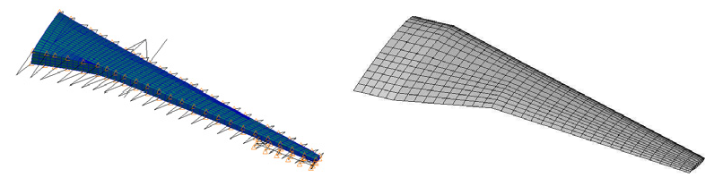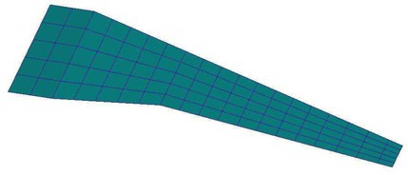

Fig. 2. (a) 3D finite element structure model; (b) High-order panel meshes; (c) Low-order panel meshes

## Result and analysis

The desired aerodynamic loading was calculated at cruise conditions of Mach 0.785 at 112000m. Aerodynamic force at 1°, 2°, 3° and 4° attack angle are separately calculated using high-order panel method and CFD method. Then the CFD results are used to make an amendment to the aerodynamic force in high-order panel method. Combined with modal method, the top-ten order elastic modal are chosen to make a static aeroelastic analysis.

The result data in this study is non-dimensioned on basis of following parameters. They are shearing force (*mg*), bending moment (*mgl*), twisting moment (*mgc*) and wing tip vertical displacement(*l*). *m* represents wing mass, *g* is gravity acceleration, *l* is reference half-wingspan, *c* is reference chord.

* 1. *Comparison of rigid aerodynamic force*

Firstly, a comparison is made before and after the correction using CFD datas. Due to limited space, 2° attack angle is considered to make the comparison of aerodynamic pressure distribution among before-and- after the revision using high-order panel method and original CFD data, as shown in Figure 3 and 4.

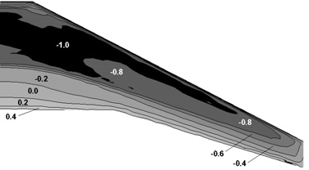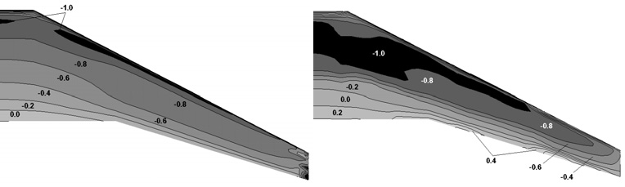

Fig. 3. (a) Aerodynamic pressure distribution by CFD (upper surface); (b) Aerodynamic pressure

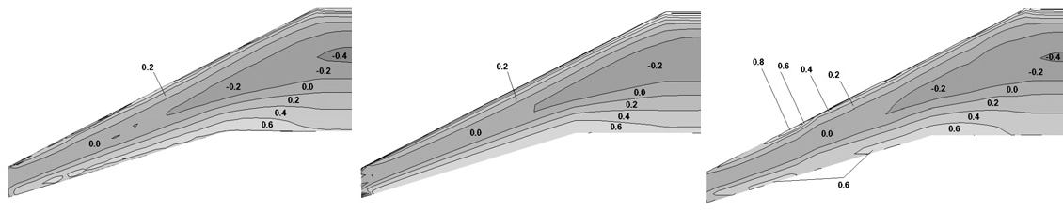distribution by high-order panel method (upper surface); (c) Aerodynamic pressure distribution after revision (upper surface)

Fig. 4. (a) Aerodynamic pressure distribution by CFD (lower surface); (b) Aerodynamic pressure distribution by high-order panel method (lower surface); (c) Aerodynamic pressure distribution after revision (lower surface)

Above contrast results show that the wing's upper and lower surface aerodynamic force is well revised in this method. The revised aerodynamic pressure and its distribution trend are well matched with that of the origin CFDs'. It is confirmed that this revise method gets good accuracy and validity.

* 1. *Variation of aerodynamic coefficient vs. angle of attack*

The variation of aerodynamic coefficient vs. angle of attack are calculated using high-order panel method, low-order panel method and CFD, when Ma=0.785, as shown in Figure 5. In the figures, ‘low- order panel method-CFD' denotes the low-order panel method result corrected with CFD data, the same as follows.

Fig.5. (a) Lift coefficient vs. attack angle; (b) Pitching moment coefficient vs. attack angle

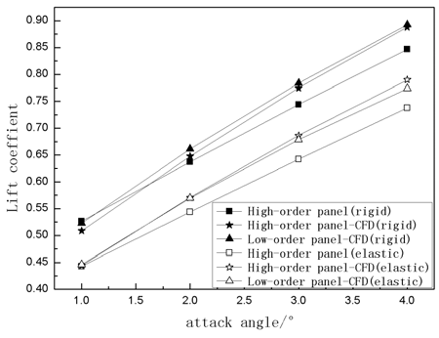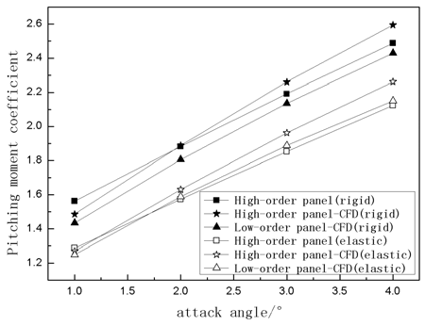

The comparison of the above figures conclude that: in rigid case, when aerodynamic force comes from high-order panel method, the aerodynamic force coefficient increases linearly with the angle of attack. Revised by CFD data, the high/low-order panel method aerodynamic force curve turns out to be a little nonlinear and the curve slope becomes larger. At the same time, it can be seen that the variation trend and numerical value of aerodynamic force coefficient curve are almost resembled between high/low-order panel method revised by CFD data.

* 1. *The variation along span of wing shearing force, bending moment and torsion moment*

There is a comparison among the different results of flight load by using high-order panel method and

high/low-order panel method whose aerodynamic force is revised by CFD data. Due to limited space, only variation of shearing force, bending moment and torsion moment are compared here, as shown in Figure 6. In the force analysis of the wing, the projection of the reference coordinate's origin point on the wing root chord is in the middle of the wing root chord. X axis is rightward along spanwise, y axis is backward and coincide with fuselage axis and z axis is upward. In this article, shearing force, bending moment and torsion moment all indicate the spanwise integral result of wing aerodynamic force in the force analysis coordinate.

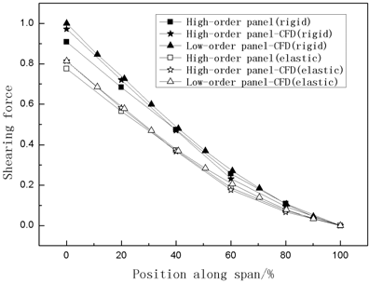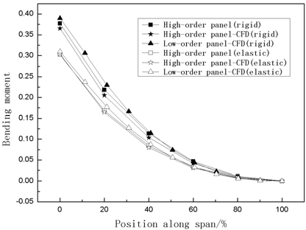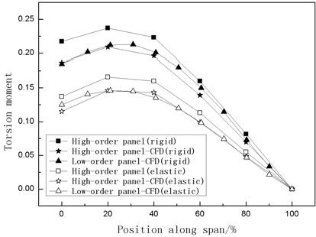

Fig.6. (a) Shearing force distribution along wingspan; (b) Bending moment distribution along wingspan; (c) Torsion moment distribution along wingspan

From the comparison of shearing force and bending moment distribution along wingspan shown above, it is clear that in rigid case, the difference about aerodynamic force numerical value and variation trend between high-order panel method and high/low-order panel method which is revised by CFD data are all very small. Then after revised in elastic further, the difference is smaller. From the comparison of the curve of torsion moment along wingspan, the difference between high-order panel method and high/low-order panel method which is revised by CFD data in the numerical value and trend in rigid and flexible cases are small. But in torsion moment distribution, the result of high-order panel method is higher than high/low- order panel method revised by CFD data. The main reason is after the CFD data revision, pressure center in chordwise move back from leading edge.

The above analysis indicates that the method of using CFD data to make a revision to the aeroeslastic force of high-order panel method is feasible, and it is suitable for the initial and detailed design stage of aircraft.

# Conclusion

This paper introduces a method that uses CFD data to revise the aerodynamic force of high-order panel method. The result is compared with the high-order panel method which is applied to the initial design stage of a plane and the low-order panel method revised by CFD data which meets the requirement in detailed design stage. The effectiveness of this method is researched by a practical case and the major conclusions can be summarized below.

1. The method using CFD data to make a revision on aerodynamic force of high-order panel method is feasible. Compared with the low-order panel method based on CFD data revision, this method can provide the pressure distribution on upper and lower surfaces of the wing, on the other hand , with high-order panel method , better result can be obtained in high subsonic and transonic case using this method.
2. The method calculates fast and precisely, can provide a more accurate static aeroelastic response analysis result for the initial and detailed design stage of an aircraft.
3. There are some differences in aerodynamic force distribution and coefficient between the high- order panel method and high/low-order panel method revise by CFD data. But the high-order panel method result gets little difference in macroscopic shear force, bending moment, torsion moment and vertical displacement at wing tip, which can still give a reference in the aircraft initial design stage.

For the limitation of aerodynamic force here, only CFD data is used to make a revision on the pressure distribution of high-order panel method to prove the effectiveness of the method. If the wind tunnel pressure distribution data could be obtained, it can also be used directly to do a revision on the pressure distribution of the high-order panel method, and the result would be more precise and more applied to the detailed design stage.

# References

1. J.H.Dehart, K.r.Cramer, S.Miller. Application of the Pan Air Production Code to a Complex Canard Wing Configuration. AIAA 21st Aerospace Sciences Meeting.
2. Joseph Katz,Allen Plotkin.Low-Speed Aerodynamics From Wing Theory to Panel Methods[M].
3. Magnus, A.E. and Epton, M.A.PANAIR-A Computer Program for predicting Subsonic or Supersonic Linear Potential Flow About Arbitrary Configurations Using a Higher Order Panel Method, Vol. I. Theory Document (Version 1.0),NASA CR0-3252,1980
4. Sidwell, K.W., Baruah,P.K., and Bussoletti,J.E., PANAIR-A Computer Program for predicting Subsonic or Supersonic Linear Potential Flow About Arbitrary Configurations Using a Higher Order Panel Method,

Vol. II. User’s Manual(Version 1.0),NASA CR0-3250,1980

1. P.C. Chen, D. Sarhaddi, D.D. Liu,M.Karpel, A Unified Aerodynamic-Influence-Coefficient Approach for Aeroelastic/Aeroservoelastic and MDO Applications.[AIAA-97-1181] 1997
2. Carol D.Wieseman, Methodology for Matching Experimental and Computational Aerodynamic Data. [NASA-TM-100592] 1988
3. Roberto Gil Annes da Silva, A STUDY ON CORRECTION METHODS FOR AEROELASTIC

ANALYSIS IN TRANSONIC FLOW. Thesis presented to the Faculty of the Division of Graduate Studies of the Technological Institute of Aeronautics, SP . Brasil, 2004.

1. P.C. Chen,R.G.A.Silva,D.D.Liu.Transonic AIC Weigh- ting Method using Successive Kernel Expansion.46th AIAA/ASME/ASCE/ASC Structures,Structural Dynamics & Materials Conference.
2. Roberto G.A.Silva, Olympio A.F. Mello, Joao Luiz F.Azevedo, P.C.Chen and D.D.Liu. Investigation on Transonic Correction Methods for Unsteady Aerodynamics and Aeroelastic Analyses. Journal of Aircraft, 2008: 1890– 1903.
3. Karpel, M. and Presente, E., Structural Dynamics Loads in Response to Impulsive Excitations. Journal of Aircraft,Nol.32,No.4,1995;853-861
4. Karpel, M. Modal-Based Enhancement of Integrated Structural Design Optimization Schemes. Journal of Aircraft,Vol.35,No.3,1998;437-444